Project Report on
Modern Restaurant

Rushikesh Bangar (51005)

Project Guide
Prof.Yogeshchandra Puranik
Academic Year- 2021-22 (Term-II)
FYMCA-Sem-II (Term-II)

P.E.S Modern College of Engineering
Academic year 2021-2022
Affiliated to Savitribai Phule Pune University, Pune.

CERTIFICATE


This is certify that Rushikesh Bangar has successfully completed the project on ‘Online food Ordering System’ for partial fulfillment of the course MCA Second Semester, affiliated to Savitribai Phule Pune University, Pune.
During the Academic Year 2021-2022.

[Dr.P.A.Muley] [Prof.Y.L.Puranik]
H.O.D, MCA Project Guide

Contents

- Introduction
- Need of the system
- Scope of the system
- Requirement of the system
- Description of the system
- Working of the system
- Flow Diagram/Flow chart
- Entity Relationship Diagram
- Screen layouts
- Future Enhancement
- Conclusion
- Bibliography

Introduction

- The aim of the project was to build a responsive online web application for restaurant which helps customers to order foods online. Along with this, the web application needs to be responsive as the application can be accessed through devices with different size of screens.
- The system, which is highly customizable, allows the restaurant employees to easily manage the site content, most importantly the menu, themselves through a very intuitive graphical interface.
- The web application, which is the only component seen by the restaurant customers, is then built online based on the current state of the system, so any changes made are reflected in real time.
- Visitors to the site, once registered, are then able to easily navigate this menu, add food items to their order, and specify delivery options with only a few clicks, greatly simplifying the ordering process. Back in the restaurant, placed orders are promptly retrieved and displayed in an easily readable format for efficient processing.

Need of the system

- The main purpose of an online ordering system is to provide customers for a way to place an order at a restaurant over the internet. So why is this important? The main reason is that it benefits both the customer and the business.

- A web application that allows customers to view the menu and place an order, and an admin interface that enables the restaurant to receive and fulfil customer orders.

- Online Ordering Systems Track Customer Data Easier.

Scope of the system

- Food Ordering System can sale Food Dishes, through this online, one- stop Food store.

- Food-order System allow customers to order from restaurant at their convenience. The customers can get their order delivered, they can pick it up themselves or they can dine in. The restaurants receive the order on the restaurant web app and prepare the meal.

- A web application that allows customers to view the menu and place an order, and an admin interface that enables the restaurant to receive and fulfil customer orders.

Requirements

Software Requirements:-
1) Platform: - Windows XP and above
2) Front End: - PHP 7.4, CSS, HTML5, JS 5, Bootstrap 5
3) Back End: - MySQL (8.0)
4) IDE: - Visual Studio Code. (17.1)

Hardware Requirements:-
- Processor: 1.0 GHz Onwards.
- RAM: 2 GB Onwards.
- Hard Disk: 250 GB onwards.

Description

Manager Module: -

Manager can create item classes and functionalities edit/erase item classes view and oversee requests and report.
User Module: -

The user module is where we go to add information about customer.
The user module allows user to register, login and logout.
Payment Module: -
Payment module is a group of payment features which can provide two type of payment methods like cash on delivery and pay using their cards.
Login Module: -
The login module is a portal module that allows users to type a username and password to log in
Contact us module:-
It displays visitors information about restaurant address, e-mail and contact number.
Feedback:-
Allows to create and conduct service to collect feedback.

Working of the system

When the user enters in the website he lands on the homepage first where he has to do registration to create user account for accessing the homepage of our system. Once the registration is done he can login in the system using his credentials. Once he enters the system he get the menu from which he can select the desired dish of his choice or also can add multiple food items in his cart.

Once the cart is ready according to his needs user can checkout towards the payment option page where he gets two payment option like cash on delivery or card payment. Now he choose any option and process towards payment.

After the payment is done user gets order id for his order and receives a screen message about the successful placement of his orders.

At the manager login manger can access the whole view of the system, he can make time to time changes according to the food availability, and also he can update prices and menu in the system

Entity Relational Diagram

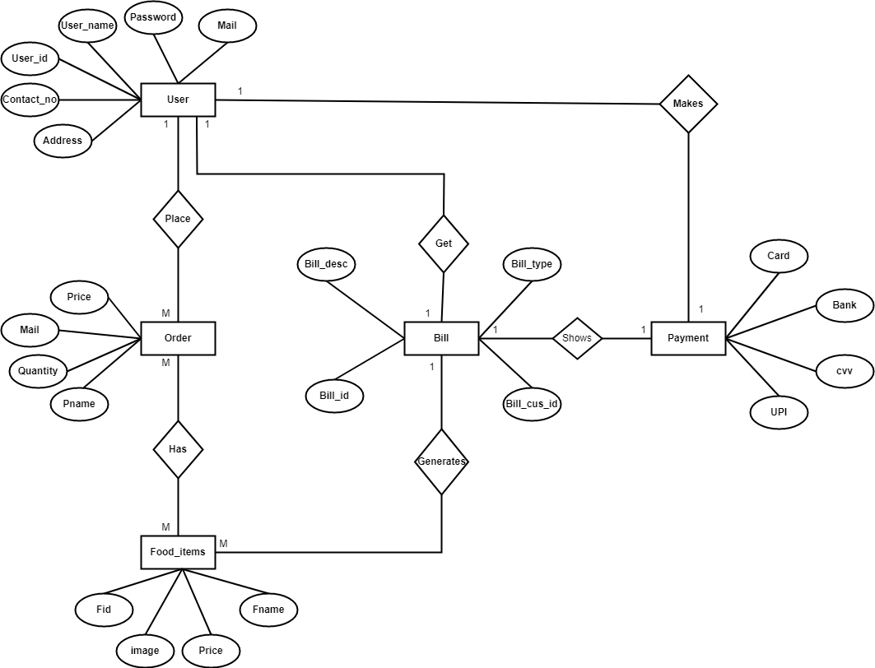

Data Flow Diagram

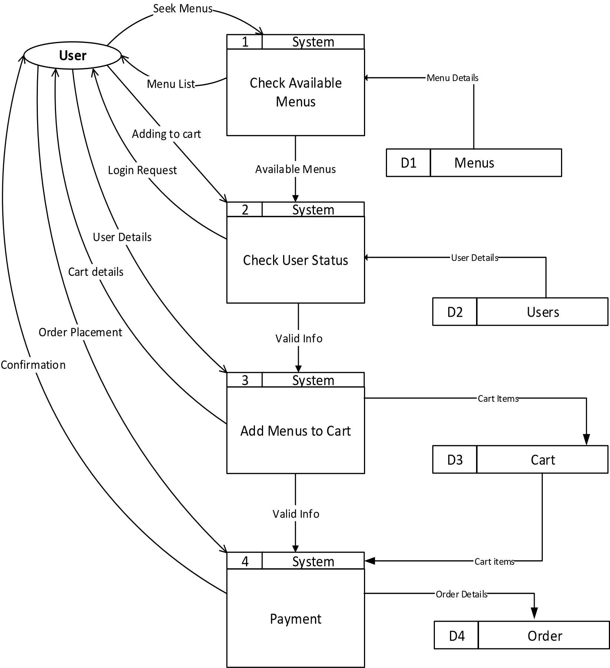

Use case diagram

- Use case Diagram: - Elicit requirement from users in meaningful chunks. Construction planning is built around delivering some use cases in each interaction basis for system testing.
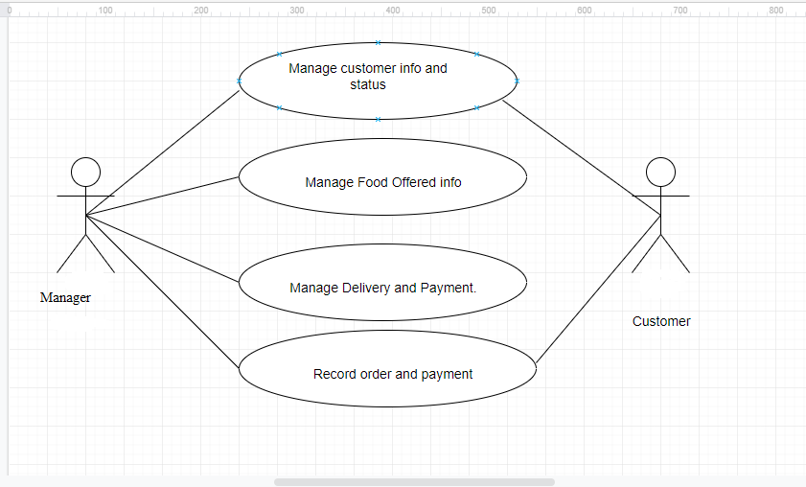
Screen layout
Home page:-
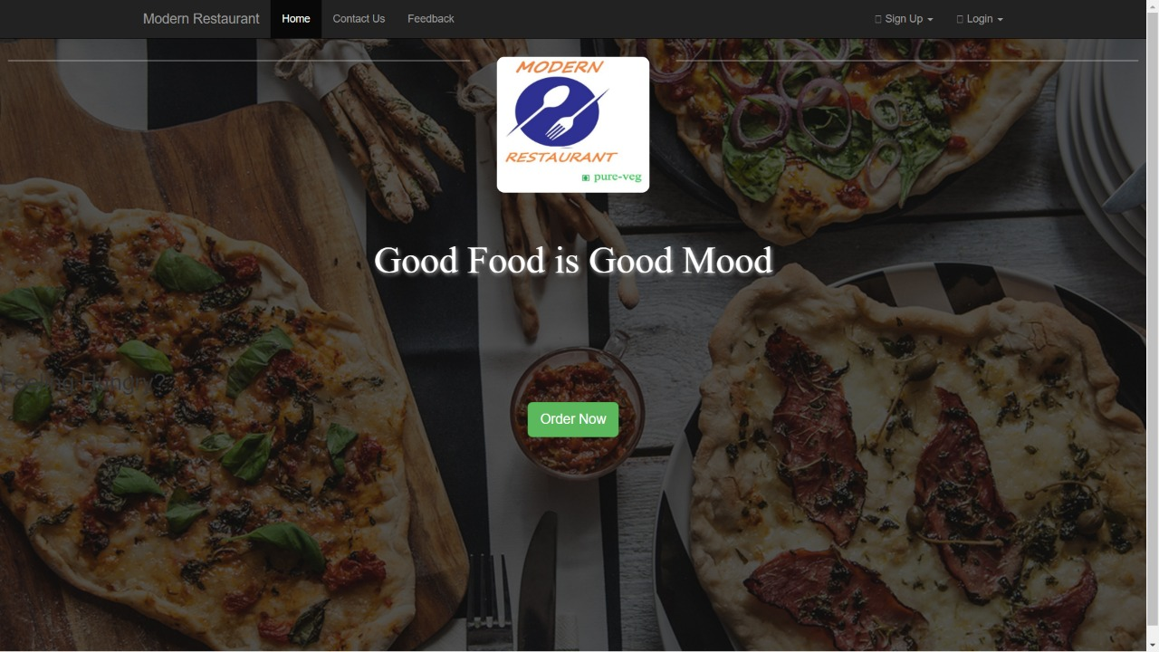Contact Us:-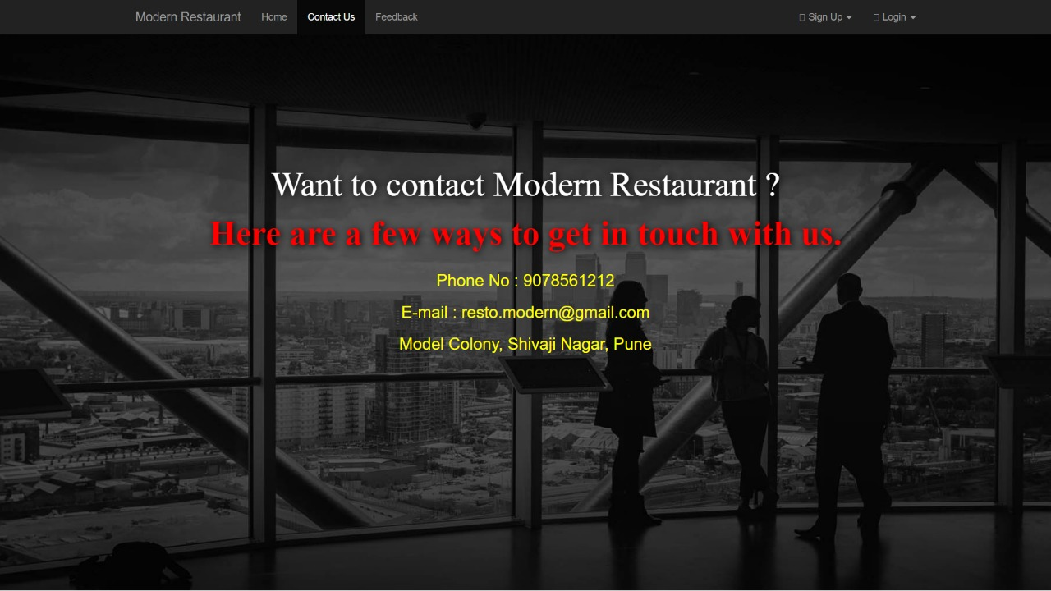

Feedback form:-
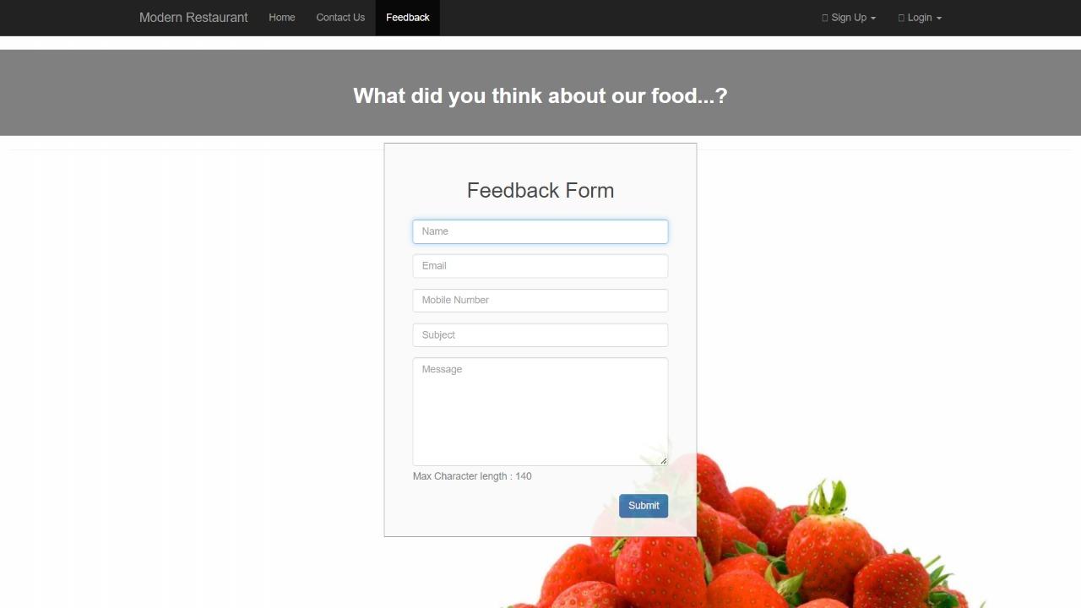
Manager Signup:-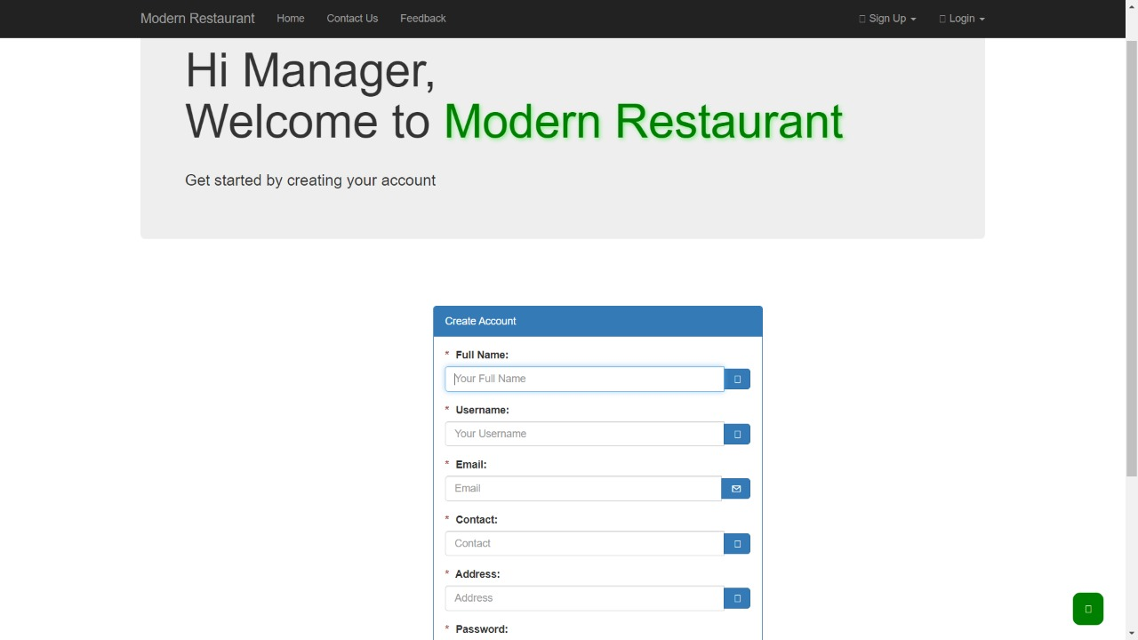

Guest Login:-
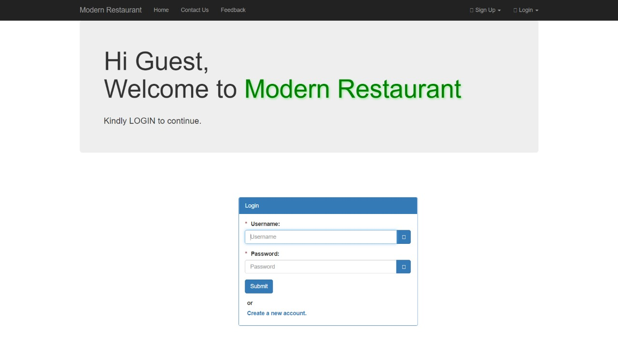
Manager Login:-Welcome page:-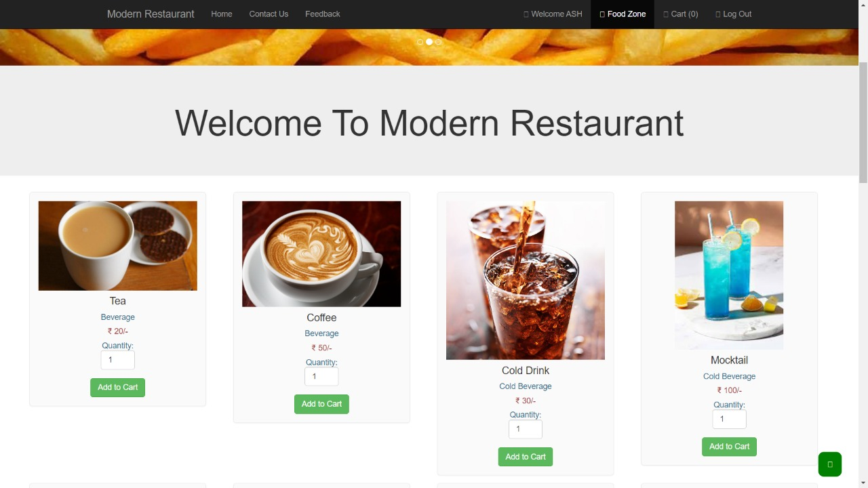
Cart:-
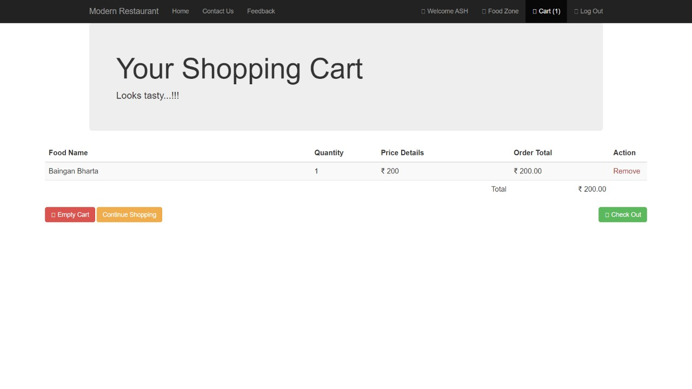
Online Payment:-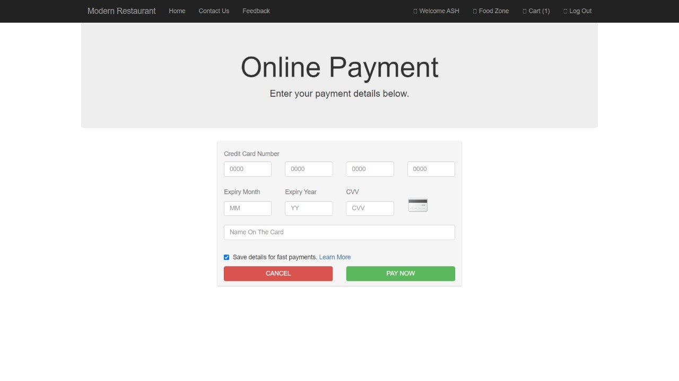Complete Order:-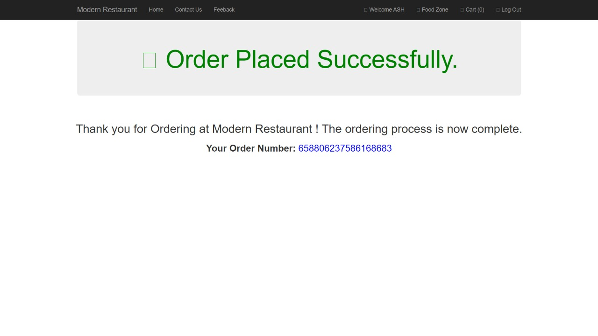

Future Enhancement

- Optimize Menu: For online ordering you don’t have sales tools so you need to bring your menu to life digitally and tempt customers with eye catching food photography. Aim to share two to three high Quality images of each menu and ensure your dishes closely resemble these when they are delivered to customers.

- Internet Banking: Banking systems that provide users access to their personal bank account for making the payment of the order which becomes easy way to pay the bill.

- Mobile App for this System: In future we will work on the system to get more user attention and get more customers using mobile app.

Conclusion

The project was successfully made according to the design and structures planned in the beginning also it gave an in-depth Knowledge of PHP, HTML, Bootstrap, Js in which the project was made and MySQL in which the database were created.

Bibliography
Web Reference: -
- https://stackoverflow.com/
- https://codewithharry.com/
- https://www.mysql.com/
- https://www.php.net/
- https://getbootstrap.com/

